#### A logo of a university Description automatically generatedA blue and white logo Description automatically generatedSoft Skills Development Platform

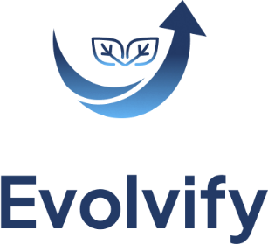

By:

**Hisham Abdalla Kamal Abdelhamid**

**Ahmad Amr Muhammad Moemen**

**Shahd Atef Fathy Mohamed**

**Nancy Khaled Khodair Hassan**

**Amira Shawky Shawky Anis**

**Ahmed Elsayed Mohamed Abdeljalil**

**Mahmoud Mohamed Mohamed Rashed**

**Ahmed Ahmed Mohamed Hassan Ibrahim**

**Alaa Mohamed Elsayed Ahmed Elfeky**

**Ahmed Saad Mohamed Elsamrawy**

Graduation Project submitted to the Faculty of Computer and Information Sciencesin partial fulfilment of the requirements for the degree of Bachelor of Science

in

**Information Systems**

Supervised by:

**Dr. Rasha Elhadary**

**Eng. Nourhan Ahmed**

Abstract

In the modern workplace, technical skills alone are not enough to ensure professional success. Employers and organizations increasingly value soft skills—such as communication, teamwork, time management, and problem-solving—for their role in effective collaboration, leadership, and productivity. Despite this importance, many individuals struggle to find structured, interactive, and engaging resources to develop these non-technical skills.

The **Evolvify** platform aims to fill this gap by providing a tailored, interactive soft skills development experience. Leveraging a personalized approach, Evolvify begins with a skill assessment quiz to understand each user's strengths and areas for growth, followed by a custom learning path focused on their unique needs. The platform’s content library includes diverse resources such as videos, articles, simulations, and practical assignments, all designed to reinforce skill application in real-world scenarios. Additionally, Evolvify incorporates an AI-powered chatbot to offer real-time support, as well as a community forum to foster peer interaction and collaborative learning.

Progress tracking and a rewards system further encourage user engagement and provide recognition for accomplishments. This structured, user-centered approach ensures not only the acquisition of essential soft skills but also their practical application and continuous improvement.

By empowering individuals with the tools and guidance they need, Evolvify aims to enhance users' career prospects, improve their workplace effectiveness, and promote a more collaborative work environment.

**Keywords** Website; Mobile application; E-learning, soft skills;

Acknowledgements

In the Name of Allah, the Most Merciful, the Most Compassionate, Alhamdulillah all praises belong to Almighty Allah, the Lord of the worlds and prayers and peace be upon Muhammad His servant and messenger.  
First and foremost, We would like to praise Allah the Almighty, the Most Gracious, and the Most Merciful for His blessing given to us during our work and in completing this project.  
May Allah's blessing goes to his final Prophet Muhammad (peace be up on him), his family and his companions.  
We would like to thank our families for backing our project with love and support, and also thank **Dr. Rasha Elhadary** for encouragement of this project and **Eng. Nourhan Ahmed** for her continuous commitment for our graduation project.

Table of Contents

Abstract I

Acknowledgements II

List of Tables V

List of Figures VI

Chapter 1: Introduction 1

1.1 Introduction 2

1.2 Problem Definition 3

1.3 Project Objectives 4

1.4 Project Scope 5

1.5 Project Timeline 6

Chapter 2: Literature Review 7

2.1 Introduction 8

2.2 Background 8

2.3 Related Work 13

2.4 Comparison of Related Work and Our Project 21

2.5 Comparison of Our Platform with Existing Solutions 22

2.6 Summary 23

Chapter 3: System Analysis 24

3.1 Introduction 25

3.2 System Requirements 25

3.3 System Architecture 28

3.4 Development Methodology 32

3.5 Summary 44

Chapter 4: System Design 45

4.1 Introduction 46

Chapter 5: System Implementation 47

5.1 Introduction 48

Chapter 6: Conclusion and Future Work 49

6.1 Conclusion 50

6.2 Future Work 50

References 51

List of Tables

**Table ‎1.1:** Project Timeline 6

**Table ‎2.1:** Comparison of Our Platform with Existing Solutions 22

Table ‎3.1: Functional Requirements 26

Table ‎3.2: Non-functional Requirements 27

List of Figures

Figure ‎2.1: Manara website 13

Figure ‎2.2: MindTools website 14

Figure ‎2.3: SkillShare website 15

Figure ‎2.4: SkillsYouNeed website 16

Figure ‎2.5: LinkedIn Learning website 17

Figure ‎2.6: Coursera application 18

Figure ‎2.7: Udemy application 19

Figure ‎2.8: Udacity website dashboard 20

Figure ‎3.1: Use case diagram 32

Figure ‎3.2: Business model canvas 34

Figure ‎3.3: Authorization sequence diagram 35

Figure ‎3.4: First-time setup sequence diagram 36

Figure ‎3.5: Community Forum sequence diagram 36

Figure ‎3.6: View Course sequence diagram 37

Figure ‎3.7: EvolviSense sequence diagram 38

Figure ‎3.8: Chatbot sequence diagram 38

Figure ‎3.9: Authorization activity diagram 39

Figure ‎3.10: First-time setup activity diagram 40

Figure ‎3.11: Community activity diagram 40

Figure ‎3.12: EvolviSense activity diagram 41

Figure ‎3.13: View course activity diagram 41

Figure ‎3.14: Chatbot activity diagram 42

Figure ‎3.15: State diagram for the project 43

# Introduction

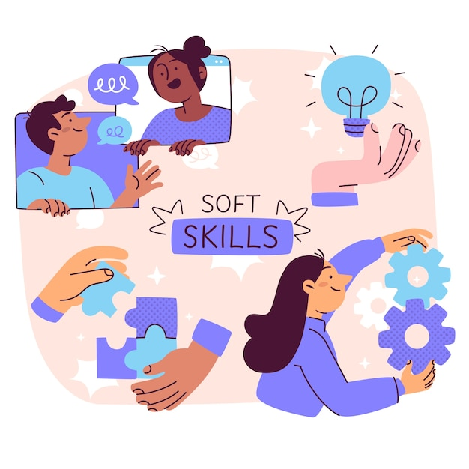

## Introduction

In today’s fast-paced workplace, soft skills—like communication, teamwork, time management, and problem-solving—are as important as technical skills. These abilities help individuals connect with others, lead effectively, and foster a positive work environment. Despite their importance, many people struggle to find structured, engaging ways to develop these non-technical skills.

**Evolvify** is here to fill that gap. Designed as a personalized, interactive platform, Evolvify helps users build essential soft skills at their own pace, ultimately boosting their career potential and workplace effectiveness. Through tailored learning paths, real-time feedback, and engaging content, users receive targeted guidance on the skills they need most. Evolvify also offers practical exercises, interactive simulations, and a supportive community where users can share insights and celebrate progress.

With tools like an AI-powered virtual coach, progress tracking, and challenges, Evolvify transforms soft skills training into an engaging journey. This approach helps users not only understand these skills but also apply and grow them in real-life scenarios. Whether preparing for a new role or enhancing existing skills, Evolvify empowers individuals to excel in today’s collaborative, dynamic work environments.

## Problem Definition

While soft skills are essential for success in today’s workplace, many individuals struggle to find resources that support effective and personalized skill development. Traditional approaches to soft skills training face several key limitations that hinder meaningful growth:

* **Limited Interactivity and Engagement**: Traditional methods, such as passive lectures or self-study modules, often lack engaging, hands-on learning elements, making it difficult for users to stay engaged or practice these skills in a practical context.
* **Lack of Personalization**: Many training programs adopt a one-size-fits-all model, overlooking the unique strengths, learning styles, and improvement areas of individual learners. This can prevent users from focusing on the skills they need most.
* **Inadequate Feedback and Progress Tracking**: Without real-time feedback mechanisms, learners may struggle to assess their progress or pinpoint specific areas where improvement is needed, making it harder to refine their skills effectively.
* **Absence of Supportive Communities**: Since soft skills are inherently social and collaborative, learning in isolation can be limiting. Without a community to share experiences and insights, users miss out on the benefits of peer learning, feedback, and real-world application.

Evolvify addresses these barriers by offering a structured, interactive learning journey designed to keep users engaged, motivated, and connected. Through practical exercises, real-time AI-assisted guidance, and a supportive community space, Evolvify provides an immersive learning experience. This approach ensures that users not only acquire essential soft skills but also feel empowered to apply them confidently and effectively in real-world scenarios, fostering both personal and professional growth.

## Project Objectives

### Provide Personalized Learning Experiences

Begin with a diagnostic quiz to assess each user’s current skill level, then create a custom learning plan that targets their unique needs. This approach allows users to concentrate on areas that align with their personal and career goals, making the learning journey more relevant and effective.

### Deliver Engaging, Interactive Content

Build a diverse content library, including videos, articles, simulations, and hands-on assignments, to keep users engaged. Interactive exercises allow users to apply skills in realistic scenarios, reinforcing learning in a way that is both impactful and memorable.

### Enable Real-Time Guidance Through AI

Integrate an AI-powered chatbot to provide instant answers, recommend content, and guide users along their learning path. This on-demand support helps users maintain momentum, boosts engagement, and creates a smooth, positive learning experience.

### Facilitate Community Interaction and Collaboration

Create a community space where users can share insights, discuss challenges, and work together. This peer interaction not only strengthens learning but also fosters a sense of belonging, encouraging users to practice their soft skills in a social context.

### Track User Progress and Recognize Achievements

Introduce progress tracking with indicators, challenges, and a rewards system to motivate users. Certifications, badges, and visual progress milestones provide a tangible sense of accomplishment, encouraging users to stay committed and continuously improve.

Through these objectives, the platform supports each user’s journey to becoming a well-rounded, skilled professional capable of thriving in today’s collaborative workplaces.

## Project Scope

The **Project Scope** of the Soft Skills Development Platform defines the key features and functionalities designed to create a personalized, engaging, and effective learning environment for users. The following elements are in scope for the project:

**In Scope**

* **Skill Assessment Quiz**:  
  A diagnostic quiz will evaluate each user's current skill levels, providing a foundation for creating a customized learning plan. This assessment will help the platform identify and recommend the most relevant content and focus areas for each user.
* **Personalized Learning Path**:  
  Based on the quiz results, users will receive tailored content recommendations aimed at enhancing essential skills, such as communication, presentation, teamwork, and time management. This feature ensures that each user's learning path aligns with their specific needs and goals.
* **Interactive Content Library**:  
  The platform will offer a diverse library of learning materials, including videos, articles, PDFs, and practical assignments, all focused on various soft skills. Users will have access to a range of resources to support their learning journey in a format that suits their preferences.
* **User Dashboard**:  
  A personalized dashboard will allow users to track their progress, view recent activity, and monitor their learning goals. This feature enables users to stay organized and motivated by providing a clear view of their achievements and areas of focus.
* **AI Chatbot**:  
  An AI-powered assistant will be available to answer user queries, provide guidance, and offer content recommendations. The chatbot will act as a virtual coach, helping users stay on track and giving them real-time support throughout their learning journey.
* **Community Forum**:  
  An online community space where users can interact, discuss challenges, share insights, and support each other. This forum will encourage collaborative learning, peer-to-peer feedback, and a sense of community among users working on similar goals.
* **Progress Tracking and Reward (Gamification)s**:  
  The platform will feature progress indicators, challenges, and a rewards system to motivate users. Visual progress tracking and rewards, such as badges or certifications, will offer users tangible recognition for their efforts and foster a sense of accomplishment.

These in-scope features establish a comprehensive platform where users can assess, develop, and track their soft skills, all while benefiting from personalized learning paths and a supportive community.

|  |  |  |  |
| --- | --- | --- | --- |
| # | Task Name | Start | Finish |
| 1 | Research | 1 September | 8 September |
| 2 | Determine Objective | 9 September | 13 September |
| 3 | Review related work and papers | 14 September | 20 September |
| 4 | Project Analysis | 21 September | 22 October |
| 5 | Design | 23 October | 3 December |
| 6 | Implementation | 4 December | 13 May |
| 7 | Testing | 14 May | 23 May |
| 8 | Integration | 24 May | 21 Jun |

**Table ‎1.1:** Project Timeline

## Project Timeline

# Literature Review



## Introduction

In this chapter, we present an overview of the essential tools and techniques required for the development of our system. Additionally, we examine the previous research conducted in relation to our system, as well as the prevalent technologies employed. Towards the conclusion of this chapter, we offer a comprehensive comparison between the system we intend to construct and the existing systems in the field.

## Background

The system we are going to build, will depend on software components, and a website and a mobile application to operate. The following subsections provide a brief background information about the equipment, tools, and techniques needed to build our system including the UI/UX design, front-end, back-end, database, networks, security, authentication and authorization and server.

### UI/UX

User experience (UX) and user interface (UI) are essential components of any digital product or service. UX focuses on the overall user experience during product interaction, while UI encompasses the visual and interactive elements that facilitate this experience. When seamlessly integrated, these elements create a cohesive and intuitive user journey. A well-designed UX ensures effortless navigation, easy access to desired information, and successful goal achievement. Conversely, an aesthetically pleasing UI enhances the overall visual appeal and engages users, resulting in a more enjoyable and memorable experience. By prioritizing user-centered design principles, companies can develop products that not only meet user needs but also surpass their expectations.

#### User Interface (UI)

The user interface (UI) refers to the visual and interactive aspect of a digital product or service, enabling users to engage with it. It encompasses the arrangement, aesthetics, and functionality of the interface, incorporating buttons, menus, forms, and other interactive elements. A thoughtfully designed UI is crucial in establishing an instinctive and seamless user experience. It should possess visual appeal, presenting information in a well-structured manner and facilitating easy navigation. Furthermore, the UI should be adaptable, catering to various devices and screen sizes. Effective UI design considers user preferences, accessibility, and usability, ensuring that users can effortlessly complete their tasks and achieve their objectives. By emphasizing simplicity, consistency, and clarity, a skillfully crafted UI enhances the overall user experience and contributes to the triumph of the digital product or service.

#### User Experience (UX)

User experience (UX) encompasses the overall satisfaction and experience that a user undergoes when interacting with a product, system, or service. It encompasses the user's emotions, perceptions, and behaviors throughout their journey. A well-executed UX design focuses on comprehending user needs, goals, and pain points, and subsequently devising effective and efficient solutions to address them. This involves conducting thorough user research, creating user personas, developing wireframes and prototypes, and continuously iterating and enhancing the product based on user feedback. A positive UX ensures that users can effortlessly navigate through the product, locate the desired information, and accomplish their tasks with minimal effort and frustration. It encompasses crucial elements such as usability, accessibility, performance, and aesthetics, all working harmoniously to deliver a seamless and delightful user experience.

### Flutter

Flutter programming is an advanced and flexible framework created by Google to develop applications for mobile, web, and desktop from a single codebase. It provides a robust and effective approach to creating visually appealing and high-performance applications with a user-friendly interface. The distinguishing feature of Flutter is its utilization of a widget-based architecture, where each element of the user interface is a widget, enabling effortless customization, reuse, and a consistent user experience across various platforms. This open-source framework utilizes the Dart programming language, renowned for its efficiency and productivity. Flutter's "hot reload" functionality enables developers to instantly see the outcomes of their code modifications, resulting in a faster and more efficient development process. With its rapid growth and strong community support, Flutter has emerged as a popular choice for developers seeking to build cross-platform applications, offering the advantages of code reusability, expressive designs, and exceptional performance. Consequently, it has become an exciting platform for mobile and web development.

### React

React is a powerful and flexible JavaScript library developed by Facebook for building user interfaces, particularly for web applications. It provides a robust and effective approach to creating visually appealing and high-performance applications through its component-based architecture. In React, every element of the user interface is encapsulated in a component, enabling effortless customization, reuse, and a consistent experience across different parts of an application. A standout feature of React is its Virtual DOM, which optimizes rendering performance by updating only the necessary parts of the actual DOM, resulting in faster and more efficient UI updates. This open-source library benefits from a vibrant ecosystem of tools and extensions—such as React Router for navigation and Redux for state management—along with strong community support. Additionally, its declarative programming style simplifies the development of interactive and dynamic interfaces, making it a popular choice for developers seeking to build scalable and maintainable web and mobile applications. With ongoing innovation and widespread industry adoption, React continues to set the standard for modern front-end development.

### Tailwind CSS

Tailwind CSS is a utility-first CSS framework that enables rapid UI development by using predefined classes directly in HTML. Instead of writing custom CSS, developers apply atomic utility classes for layout, spacing, typography, and colours, ensuring consistency and reducing the need for external stylesheets.

Tailwind's customizability is a key feature, allowing developers to configure design systems through the tailwind.config.js file, making it adaptable to any project. Its built-in responsive design utilities and purge feature optimize performance by eliminating unused CSS in production, leading to smaller file sizes.

With a growing ecosystem of plugins and strong community support, Tailwind CSS offers a flexible, efficient approach to building scalable, maintainable web applications, making it a go-to choose for modern front-end development.

### Artificial Intelligence (AI)

AI, a field of computer science, is focused on developing systems that can perform tasks requiring human intelligence. It encompasses various technologies such as machine learning, deep learning, natural language processing, and computer vision. These technologies enable computers and machines to analyze data, learn, make decisions, and solve complex problems independently. AI has made significant progress in domains like healthcare, finance, self-driving cars, and virtual assistants, with the potential to revolutionize industries, improve efficiency, and enhance decision-making. However, it also raises ethical and societal concerns regarding privacy, bias, and job displacement, leading to ongoing debate and research. As AI continues to evolve, its applications and impact on our daily lives are expanding, promising to shape the future of technology and human-machine interactions.

### .NET

Microsoft has developed the .NET programming framework to cater to a wide range of application development needs. This versatile and powerful framework allows developers to create desktop, web, mobile, and cloud-based applications. By utilizing languages such as C# and VB.NET, developers can build robust and efficient software in a consistent and scalable environment. The Common Language Runtime (CLR) is a key feature of .NET, as it manages memory, handles exceptions, and enables interoperability between different programming languages. With an extensive class library and integrated development tools, .NET simplifies the development process, promotes code reuse, and enhances productivity. It supports various application architectures and deployment models, making it suitable for diverse development scenarios. The introduction of .NET Core, an open-source and cross-platform version of .NET, has further expanded its capabilities, allowing developers to build and deploy applications on Windows, Linux, and macOS. Overall, .NET programming empowers developers to create high-quality, scalable, and modern software solutions across multiple platforms and devices.

### OpenCV

OpenCV is an open-source library that focuses on providing pre-developed functions for computer vision projects. Originally written in C and C++, the functions have also been converted for other languages such as Python, Java, and MATLAB. The library provides helpful functions in not only the basic image processing techniques but also different Gesture detection algorithms. Few applications of Open CV library have been given below [1]:

* Facial Recognition
* Segmentation
* Augmented Reality
* Motion Tracking
* Gesture Recognition

OpenCV is a cross-platform library, it can run on desktop platforms such as Windows, Linux, and macOS and mobile platforms such as Android and iOS.

## Related Work

### Manara

A talent-focused learning platform that provides mentorship and training for professionals in the tech industry. As a competitor, we analyzed its strengths and weaknesses:

**Pros:**

1. Personalized mentorship from industry experts.
2. Strong networking opportunities with top companies.
3. Career-focused training tailored for job placement.
4. High-quality technical and soft skills development.

**Cons:**

1. Limited access without application and acceptance.
2. Focused mainly on tech careers, not broader soft skills.
3. Less interactive AI-based training.
4. No self-paced learning options.

Figure ‎2.1: Manara website

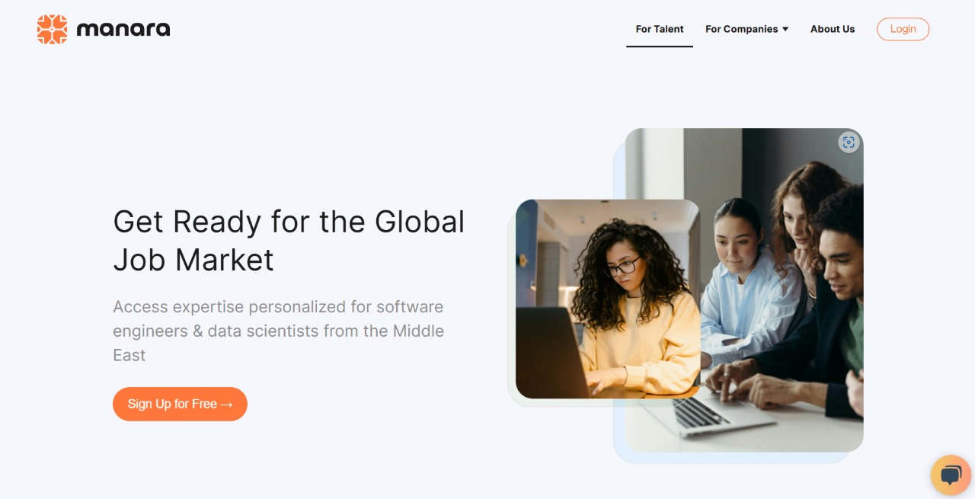

### MindTools

An online learning platform providing self-improvement resources for leadership, management, and personal development.

**Pros:**

1. Extensive resources on leadership and soft skills.
2. Well-structured learning paths for career growth.
3. Covers a broad range of professional skills.
4. Easy-to-digest content for quick learning.

**Cons:**

1. Requires a subscription for full access.
2. Lacks interactive and AI-based assessments.
3. Focuses more on theory rather than practical application.
4. No real-time feedback on performance.

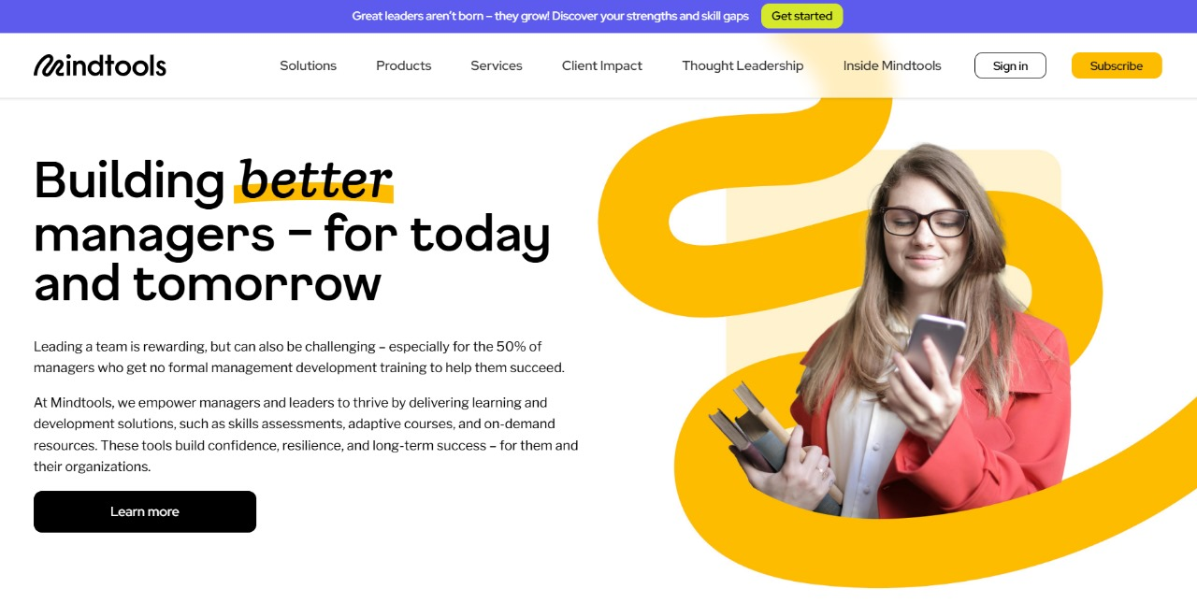

Figure ‎2.2: MindTools website

### SkillShare

An online learning platform that provides user-generated courses in creative and professional skills.

**Pros:**

1. Wide variety of courses covering creative and professional topics.
2. Affordable subscription model with unlimited access.
3. Community-driven learning experience.
4. Hands-on project-based approach.

**Cons:**

1. Course quality varies as content is user-generated.
2. Lacks structured career paths and certifications.
3. No AI-based feedback or analysis tools.
4. Limited focus on corporate soft skills development.

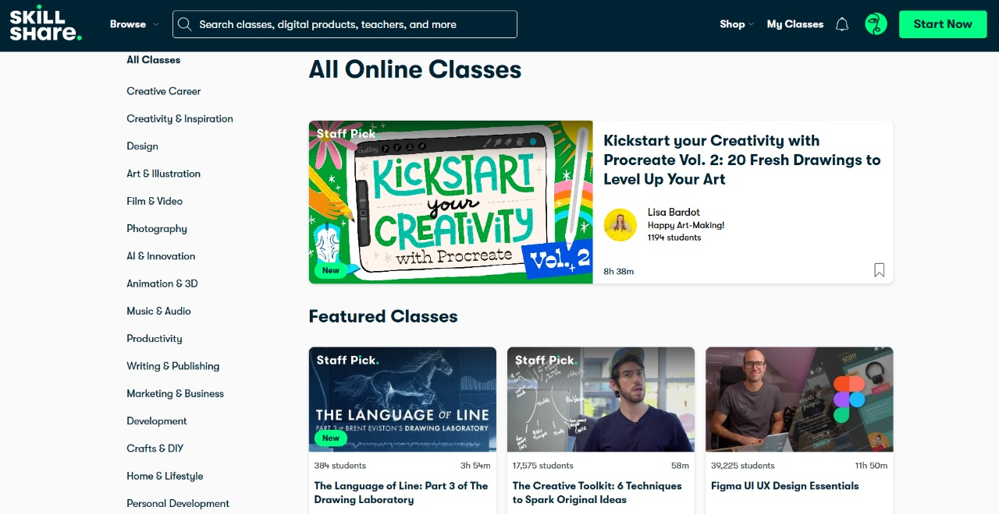

Figure ‎2.3: SkillShare website

### SkillsYouNeed

A free educational website offering articles and guides for personal and professional skill development.

**Pros:**

1. Free and accessible learning resources.
2. Covers a broad range of soft skills topics.
3. Well-structured articles for self-paced learning.
4. Useful for beginners looking to improve communication and leadership skills.

**Cons:**

1. No interactive training or practical exercises.
2. No certification or structured courses.
3. Limited engagement and community interaction.
4. 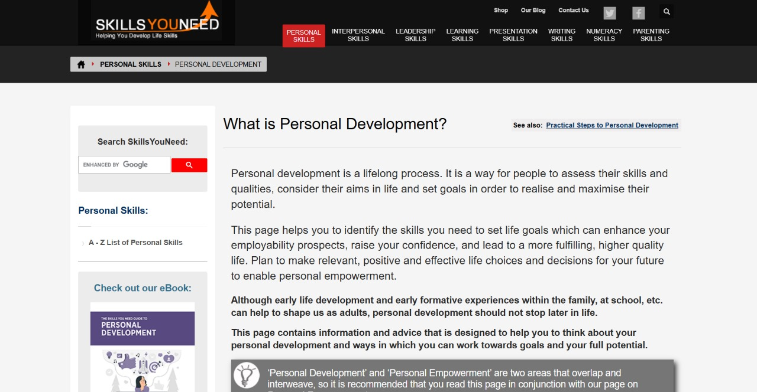Unappealing user interface.

Figure ‎2.4: SkillsYouNeed website

### LinkedIn Learning

A professional development platform offering expert-led courses in various fields, including soft skills and career advancement.

**Pros:**

1. High-quality content from industry professionals.
2. Integration with LinkedIn for career tracking.
3. Certification upon course completion.
4. Personalized recommendations based on user profile.

**Cons:**

1. Requires a paid subscription for full access.
2. Less emphasis on interactive training.
3. Lacks AI-driven performance analysis.
4. Limited community engagement features.

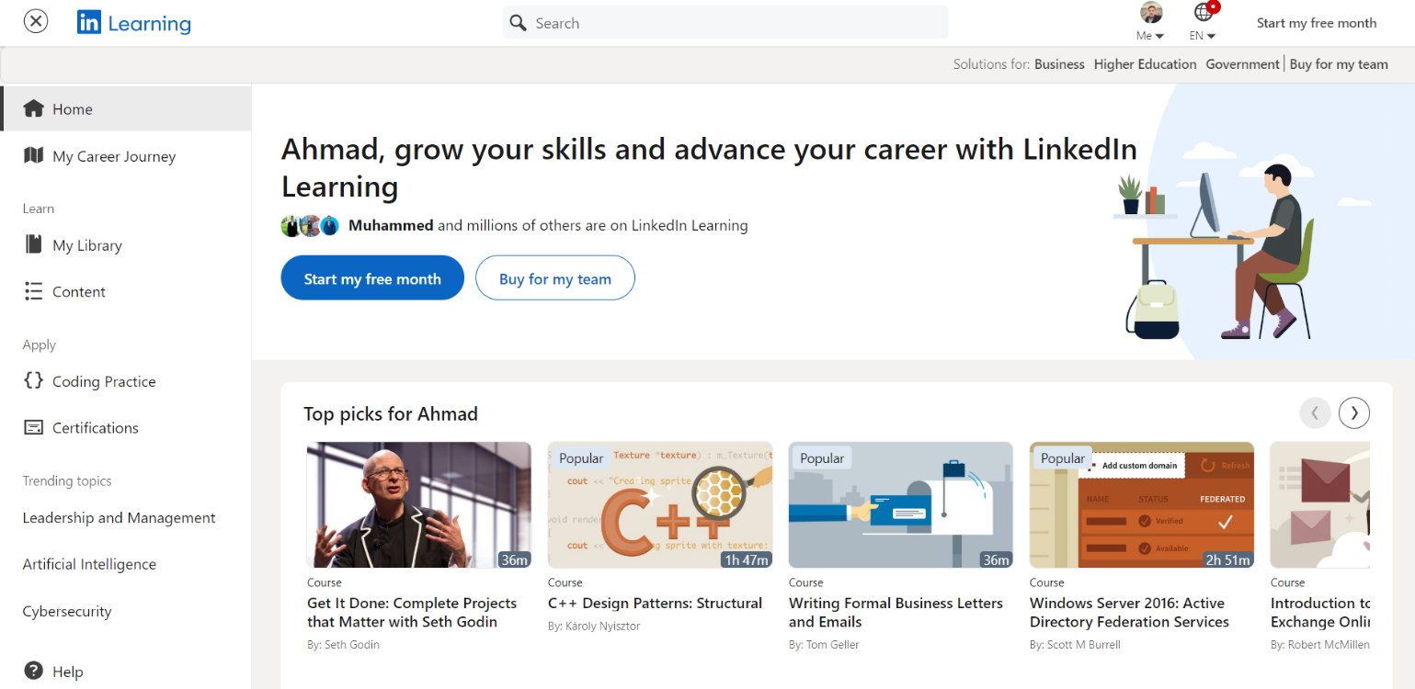

Figure ‎2.5: LinkedIn Learning website

### Coursera

An online learning platform offering university-level courses and certifications in multiple domains.

**Pros:**

1. Recognized certifications from top universities.
2. In-depth, structured courses with high academic quality.
3. Self-paced and flexible learning options.
4. Wide range of subjects, including soft skills.

**Cons:**

1. Most certifications require payment.
2. Less focus on interactive soft skills training.
3. No real-time AI-based performance feedback.
4. Interaction is mostly through discussion forums.

Figure ‎2.6: Coursera application



### Udemy

A global learning marketplace offering courses in various fields, including business, technology, and personal development.

**Pros:**

1. Wide variety of affordable courses.
2. Self-paced learning with lifetime access.
3. Interactive video-based content.
4. Frequent discounts and promotions.

**Cons:**

1. Course quality varies as content is user-generated.
2. No structured career paths or accreditation.
3. Lacks AI-driven performance analysis.
4. No direct mentorship or real-time guidance.

Figure ‎2.7: Udemy application



### Udacity

A tech-focused online learning platform offering nano-degree programs in various domains.

**Pros:**

1. Industry-relevant courses developed with top companies.
2. Project-based learning with hands-on experience.
3. Career services and mentorship support.
4. Recognized certifications for career advancement.

**Cons:**

1. Expensive compared to other platforms.
2. Limited focus on soft skills and personal development.
3. High commitment required for nano-degree programs.
4. No AI-based real-time feedback.

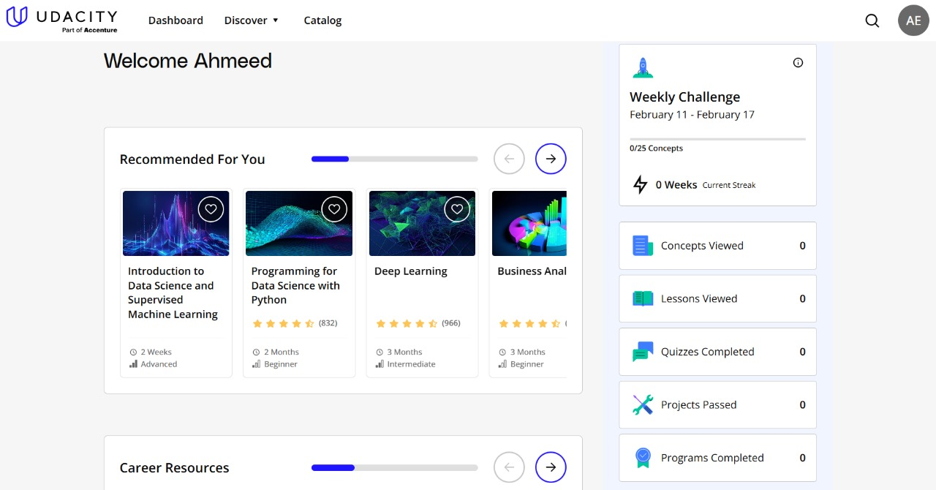

Figure ‎2.8: Udacity website dashboard

## Comparison of Related Work and Our Project

* **Skill Assessment Quiz:**

Our platform provides an AI-driven quiz to evaluate users' soft skills and deliver tailored recommendations for improvement. In contrast, most existing platforms either lack quizzes entirely (MindTools) or offer only general, self-paced quizzes (LinkedIn Learning, Udemy).

* **Personalized Roadmap:**

Our platform generates a customized learning roadmap based on users' interests and skill assessment results, ensuring a focused approach to skill development. Other platforms, such as SkillShare and LinkedIn Learning, only offer general course suggestions without customization.

* **User Dashboard**:

We include a comprehensive user dashboard to track learning progress, access the roadmap, and revisit recent courses. Other platforms, including Coursera and Udemy, offer only basic tracking or limited dashboard functionality.

* **AI Chatbot**:

A unique feature of our platform is a 24/7 AI chatbot that provides users with immediate assistance and content guidance, ensuring they have continuous support throughout their learning journey. None of the existing platforms offer this level of AI-driven assistance.

* **Community Forum**:

Our platform includes an interactive forum where users can discuss topics, seek advice, and support each other. This feature fosters a collaborative learning environment. Platforms like Coursera offer limited discussion spaces tied to specific courses, but there is no broad, interactive forum feature.

* **Educational Videos and Resources:**  
  We provide educational videos accompanied by detailed descriptions, PDFs, and assignments for hands-on practice. In contrast, MindTools lacks video content, while other platforms (SkillShare, LinkedIn Learning) typically limit resources to videos without supplementary materials or interactive assignments

## Comparison of Our Platform with Existing Solutions

**Table ‎2.1:** Comparison of Our Platform with Existing Solutions

|  |  |  |  |  |  |  |
| --- | --- | --- | --- | --- | --- | --- |
| **Website/Feature** | **Skill Assessment Quiz** | **Personalized Roadmap** | **User Dashboard** | **AI Chatbot for Assistance** | **Community Forum** | **Educational Videos & Resources** |
| **Our Platform**  (Evolvify) | AI-driven quiz evaluates skills and sets up tailored recommendations | Customized learning roadmap based on interests and AI quiz results | Tracks progress, displays roadmap, and accesses recent courses | 24/7 AI chatbot for general help and content guidance | Interactive forum for user discussion and peer support | Videos with detailed descriptions, PDFs, and assignments |
| **Manara** | No personalized quiz | Personalized mentorship, no roadmap | Tracks progress for mentorship | None | Strong networking opportunities | Focus on mentorship, no extensive educational resources |
| **MindTools** | No quizzes, articles only | No roadmap | No dashboard | None | None | No videos, articles only |
| **SkillShare** | Basic self-assessment | General course suggestions | Limited dashboard | None | None | Video courses only |
| **SkillsYouNeed** | No quizzes, articles only | No roadmap | No dashboard | None | None | Articles and guides only |
| **LinkedIn Learning** | No personalized quiz | General course suggestions | Basic progress tracker | None | None | Video only with few resources |
| **Coursera** | Self-paced quizzes at the end of courses | Roadmap by course | Course tracking only | None | Course discussion only | Text and some videos |
| **Udemy** | General quizzes | None | Basic tracking | None | None | Video courses only |
| **Udacity** | No AI-based quiz | Project-based learning, industry-relevant certifications | Tracks progress | None | None | Videos with projects |

## Summary

* **Project Value and Importance**:

Our project uniquely addresses the need for comprehensive, interactive, and personalized soft skills training. By combining AI-driven assessments, customized roadmaps, a user dashboard, an AI chatbot, and a community forum, our platform provides a more holistic and engaging learning experience.

* **Bridging Existing Gaps**:

With its unique features, our platform fills the gaps left by existing solutions, offering users a well-rounded approach to mastering essential soft skills needed for professional success

# System Analysis21,104 System Analysis Illustrations - Free Download in SVG, PNG, EPS | IconScout

## Introduction

Evolvify is designed to facilitate the enhancement of essential soft skills through a personalized, engaging, and interactive learning experience. This section outlines the key components of the project, including the business model, system requirements, use cases, architecture, information flow, tools used, and a summary of the overall approach. Each element plays a crucial role in ensuring that the platform meets the needs of its users and achieves its objectives effectively.

## System Requirements

A successful software project requires a thorough understanding of both functional and non-functional requirements. Functional requirements outline what the system must do, while non-functional requirements describe how the system performs its tasks. For Evolvify, these requirements encompass user interactions, content access, performance benchmarks, and security measures necessary to protect user data. This section provides a comprehensive overview of the system requirements, ensuring that the platform is robust, user-friendly, and secure.

### Functional Requirements

These are the requirements that the end user specifically demands as basic facilities that the system should offer. These are represented or stated in the form of input to be given to the system, the operation performed, and the output expected. In this subsection, we list the functions required in our system. We, also, provide a description for each function Table 3.1. shows the functional requirements for our system.

Table ‎3.1: Functional Requirements

|  |  |  |
| --- | --- | --- |
| **#** | **Functional Requirement** | **Description** |
| FR01 | User Registration and Login | Users must be able to create an account and log in to access the platform. |
| FR02 | Profile Management | Users can view and update their personal information. |
| FR03 | Personalized Learning Path Selection | The platform should allow users to choose personalized learning paths based on their interests and current skill levels. |
| FR04 | Interactive Trainings | Provide interactive training modules such as presentation practice and job interview simulations. |
| FR05 | AI Stress Analysis | Analyze users' stress levels during training sessions using facial expression and voice analysis. |
| FR06 | Progress Dashboard | Display user progress and analytics through an interactive, user-friendly dashboard. |
| FR07 | Content Management | Allow administrators or trainers to add, update, or remove educational content and training modules. |
| FR08 | Notifications and Alerts | Send notifications to users regarding upcoming training sessions, updates, and post-training results. |
| FR09 | Integration with External Services | Support integration with external tools or platforms to enhance the learning and analysis process. |
| FR10 | Gamification and Rewards | Implement gamification elements (e.g., badges, points, leaderboards) to motivate users and enhance engagement. |
| FR11 | Social Interaction and Collaboration | Provide forums, chat rooms, or group activities to foster peer-to-peer interaction and collaborative learning. |
| FR12 | Adaptive Learning | Dynamically adjust learning paths and content based on user performance and feedback to offer a personalized learning experience. |
| FR13 | Assessment and Quizzes | Incorporate quizzes and tests at the end of modules to evaluate user understanding and progress. |
| FR14 | Feedback and Reviews | Enable users to provide feedback and rate courses or training sessions to help improve the overall content quality and user experience. |
| FR15 | Scheduling and Calendar Integration | Allow users to schedule training sessions and sync them with external calendar applications (e.g., Google Calendar, Outlook). |
| FR16 | Reporting and Analytics for Administrators | Provide detailed reports and analytics for administrators to monitor user performance, content effectiveness, and platform usage. |
| FR17 | API Integration | Support integration with third-party APIs (e.g., for notifications, calendar synchronization, and additional content sources) to enhance platform functionality. |
| FR18 | Live Training Sessions | Offer real-time, interactive live sessions such as webinars, workshops, or group discussions led by industry experts. |
| FR19 | Multi-Modal Content Delivery | Support various content formats including video, audio, text, and interactive modules to accommodate different learning styles. |
| FR20 | Personalized Notifications | Send customized notifications based on user progress, upcoming sessions, and new content releases to keep users engaged and informed. |
| FR21 | Skill Assessment and Certification | Provide tools for users to take assessments that measure their soft skills and offer certificates or digital badges upon successful completion. |

### Non-Functional Requirements

Non-functional requirements cover all the remaining requirements which are not covered by the functional requirements. They specify criteria that judge the operation of a system, rather specific behaviors. Table 3.2 shows the nonfunctional requirements for our system.

Table ‎3.2: Non-functional Requirements

|  |  |  |
| --- | --- | --- |
| **#** | **Non-Functional Requirement** | **Description** |
| NFR01 | Security and Privacy | Protect user data using encryption protocols and standard security measures. |
| NFR02 | Performance | Ensure the system responds quickly and supports many users without delays. |
| NFR03 | Compatibility | Ensure the platform works across various devices (mobile, tablet, desktop) and major web browsers. |
| NFR04 | Usability | Provide an intuitive and user-friendly interface to accommodate users of all experience levels. |
| NFR05 | Scalability | Design the system to easily add new features or support an increasing number of users without performance loss. |
| NFR06 | Reliability | Guarantee stable system operation with minimal downtime and high availability. |
| NFR07 | Maintainability | Utilize an architectural design that simplifies updates and maintenance without major disruptions. |
| NFR08 | Multi-Language Support and Localization | Provide a multi-language interface to cater to users from diverse cultural backgrounds. |
| NFR09 | Real-Time Responsiveness | Deliver real-time analysis of stress levels during training sessions for immediate user feedback. |
| NFR10 | Compliance with Standards | Adhere to industry and legal standards for data privacy and security (e.g., GDPR, local regulations). |

.

### User Requirements

These describe what the users need from the system and how they will interact with it.

**● Target Users**

○ Professionals seeking to improve their soft skills.

○ Students preparing for internships or job interviews.

○ Organizations looking to enhance employee training programs.

**● User Goals**

○ Users want to assess their current soft skills and identify areas for improvement.

○ Users wish to access high-quality, interactive resources for learning and practice.

○ Users need a platform to track their progress and receive feedback.

**● User Experience**

○ Users expect a responsive design that works well on both desktop and mobile devices.

○ Users prefer personalized content that adapts to their learning pace and style.

○ Users desire a community where they can share experiences and learn from others.

## System Architecture

In this part of the chapter, we will explain the application architecture, with precisely what type of dealing and every process the user can do, after determining the requirements of the application, we will describe its (structures), and how the user can interact with it.

### Architectural Design

In this section, provide an overview of the system's main components and how they interact. Include a high-level diagram (such as a layered architecture or component diagram) that illustrates the front end, back end, database, and any third-party services.

**● Frontend**: Built using React.js with Tailwind CSS for styling, responsible for rendering the user interface, user dashboard, and interactive components such as skill assessment quizzes and forums.

**● Backend**: Powered by C#, ASP.NET Core, utilizing LINQ and Entity Framework to handle API requests, user authentication, and secure data management.

**● Database**: Utilizes SQL Server to manage user data, course materials, forum discussions, and progress tracking.

**● Third-Party Services**: Integrates Cloudinary for image uploads, JWT for user authentication, and a custom AI chatbot API.

#### Data Flow and Component Interaction

Explain how data flows through the system from user interaction to backend processing and back. This part might detail the following:

**● User Actions**: Describe common user actions like logging in, taking quizzes, and watching videos, and how these actions trigger backend processes.

**● API Endpoints**: List key API endpoints and their roles.

**● Frontend-Backend Communication**: Explain how React interacts with the backend through HTTP requests and how responses update the frontend.

#### Security and Authentication

Discuss how user data is protected, including the use of:

**● JWT (JSON Web Token)** for secure, session-based authentication.

**● Bcrypt** for encrypting user passwords.

**● Role-Based Access**: Describe access control for different users (e.g., admin, standard user).

#### Scalability and Future Growth

Explain the potential for scaling the system, such as:

**● Database Scaling**: Using MongoDB’s scalability features for handling a growing amount of user data.

**● Load Balancing**: Future implementation of load balancers to distribute traffic evenly across servers.

### Architectural Structure

#### Component Descriptions

**● Client-Side (Frontend)**

**○ User Interface (UI):** Developed using HTML, CSS, JavaScript, and React framework for responsive design.

**○ Resource Library**: A section where users can access articles, videos, and interactive exercises related to soft skills.

**○ Quiz Module**: Allows users to take assessments for various soft skills, providing immediate feedback and insights.

**○ Progress Tracker**: Displays user progress, achievements, and areas for improvement.

**● Server-Side (Backend)**

**○ Authentication Service**: Manages user registration, login, password recovery, and session management (using JWT, OAuth, etc.).

**○ Learning Path Recommendation**: Analyzes user assessment results and provides personalized content recommendations.

**○ Quiz Management**: Handles quiz creation, evaluation, and storage of results.

**○ User Management**: Manages user profiles, preferences, and data storage.

**● Database**

○ **User Data**: Stores user profiles, including personal information and   
skill assessment history.

○ **Quiz Results**: Records scores, feedback, and progress for each user assessment.

○ **Resource Data**: Contains articles, videos, and exercises organized by skill.

○ **Progress Data**: Tracks user’s learning journey and milestones.

#### Technology Stack

**● Frontend**: HTML5, CSS3, Tailwind CSS, JavaScript, React.js.

**● Backend**: C#, LINQ, Entity Framework Core, Asp.NET Core

**● Database**: SQL Server

**● Mobile Development**: Flutter (Dart)

## Development Methodology

This section outlines our development methodology and the key diagrams used to map out functionalities and interactions in our soft skills platform.

### Use Case Diagram

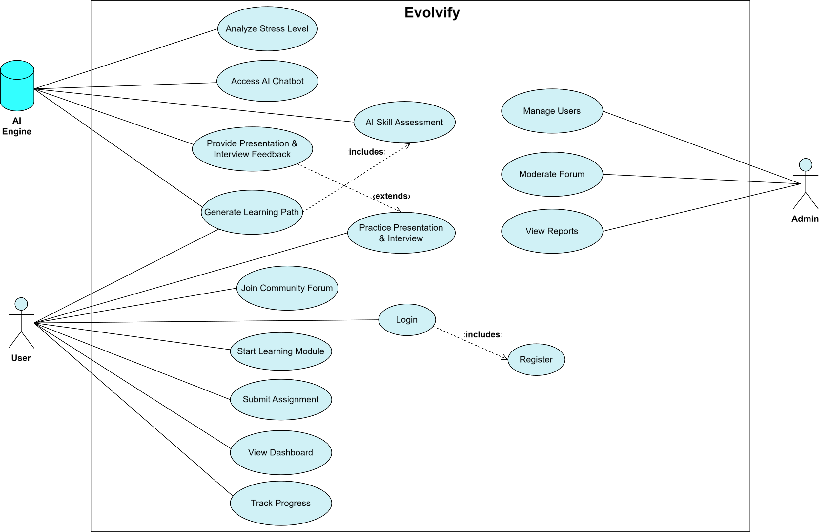The Use Case Diagram presents the primary interactions between users (such as learners, content creators, and administrators) and the platform. It visualizes core functionalities, including skill assessments, accessing educational content, user account management, AI chatbot interactions, and community forum engagement. This high-level view highlights user roles and the services they interact with.

Figure ‎3.1: Use case diagram

### Use Case Description (Detailed Use Cases)

Detailed Use Cases provide a clear, step-by-step breakdown of each platform feature. For each use case, the following details are included:

**● Register**: User creates a new account.

**● Login**: User logs into their account.

**● View Dashboard**: User views their personalized dashboard with progress and recommendations.

**● AI Skill Assessment**: User completes a skill assessment and receives feedback.

**● Generate Learning Path**: AI creates a customized learning path based on the user’s skill level.

**● Access AI Chatbot**: User interacts with the AI chatbot for guidance.

**● Join Community Forum**: User participates in discussions with other users.

**● Start Learning Module**: User begins a learning module to develop specific skills.

**● Submit Assignment**: User completes and submits an assignment.

**● Practice Presentation**: User practices a presentation and receives AI feedback.

**● Provide Presentation Feedback**: AI evaluates the presentation and gives feedback.

**● Practice Interview**: User practices interview skills and receives AI feedback.

**● Provide Interview Feedback**: AI evaluates the interview and gives feedback.

### Business Model Canvas

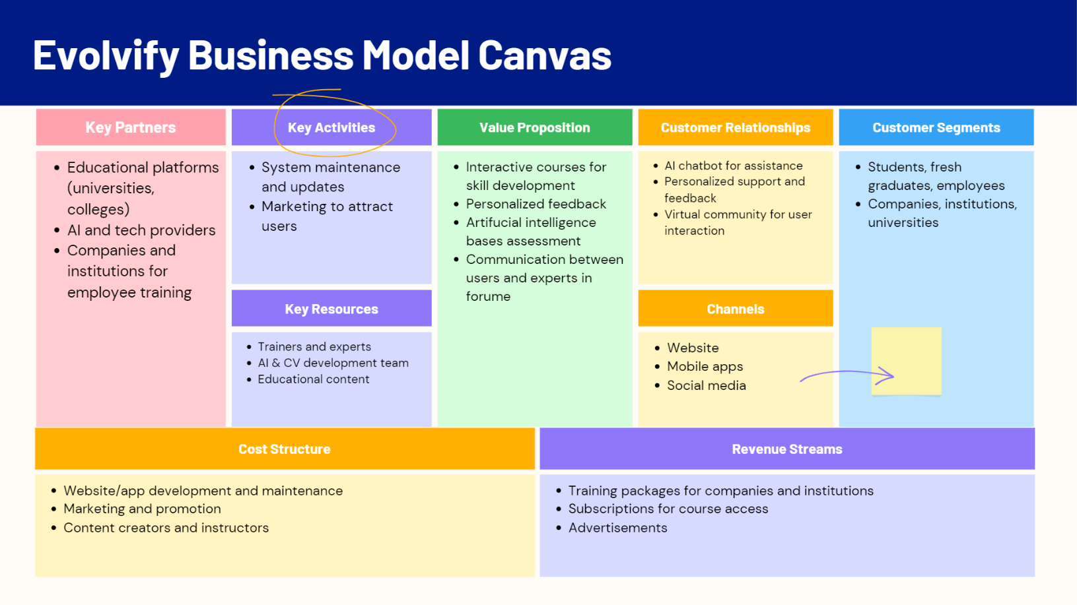To effectively visualize and strategize the business model for Evolvify, we utilize the Business Model Canvas framework. This tool helps clarify the value proposition, customer segments, revenue streams, and key activities that will drive the platform’s success. By clearly defining these elements, we can ensure that Evolvify meets its target audience's needs while being financially viable. This section details each component of the Business Model Canvas, illustrating how Evolvify plans to create value and sustain operations.

Figure ‎3.2: Business model canvas

### Sequence Diagrams

The Sequence Diagram outlines the flow of communication among system components for each key use case. It shows the order of messages and events exchanged between the frontend, backend, and database, covering actions like quiz submissions, content access, or community forum participation. These diagrams clarify how each system component processes and responds to user requests.

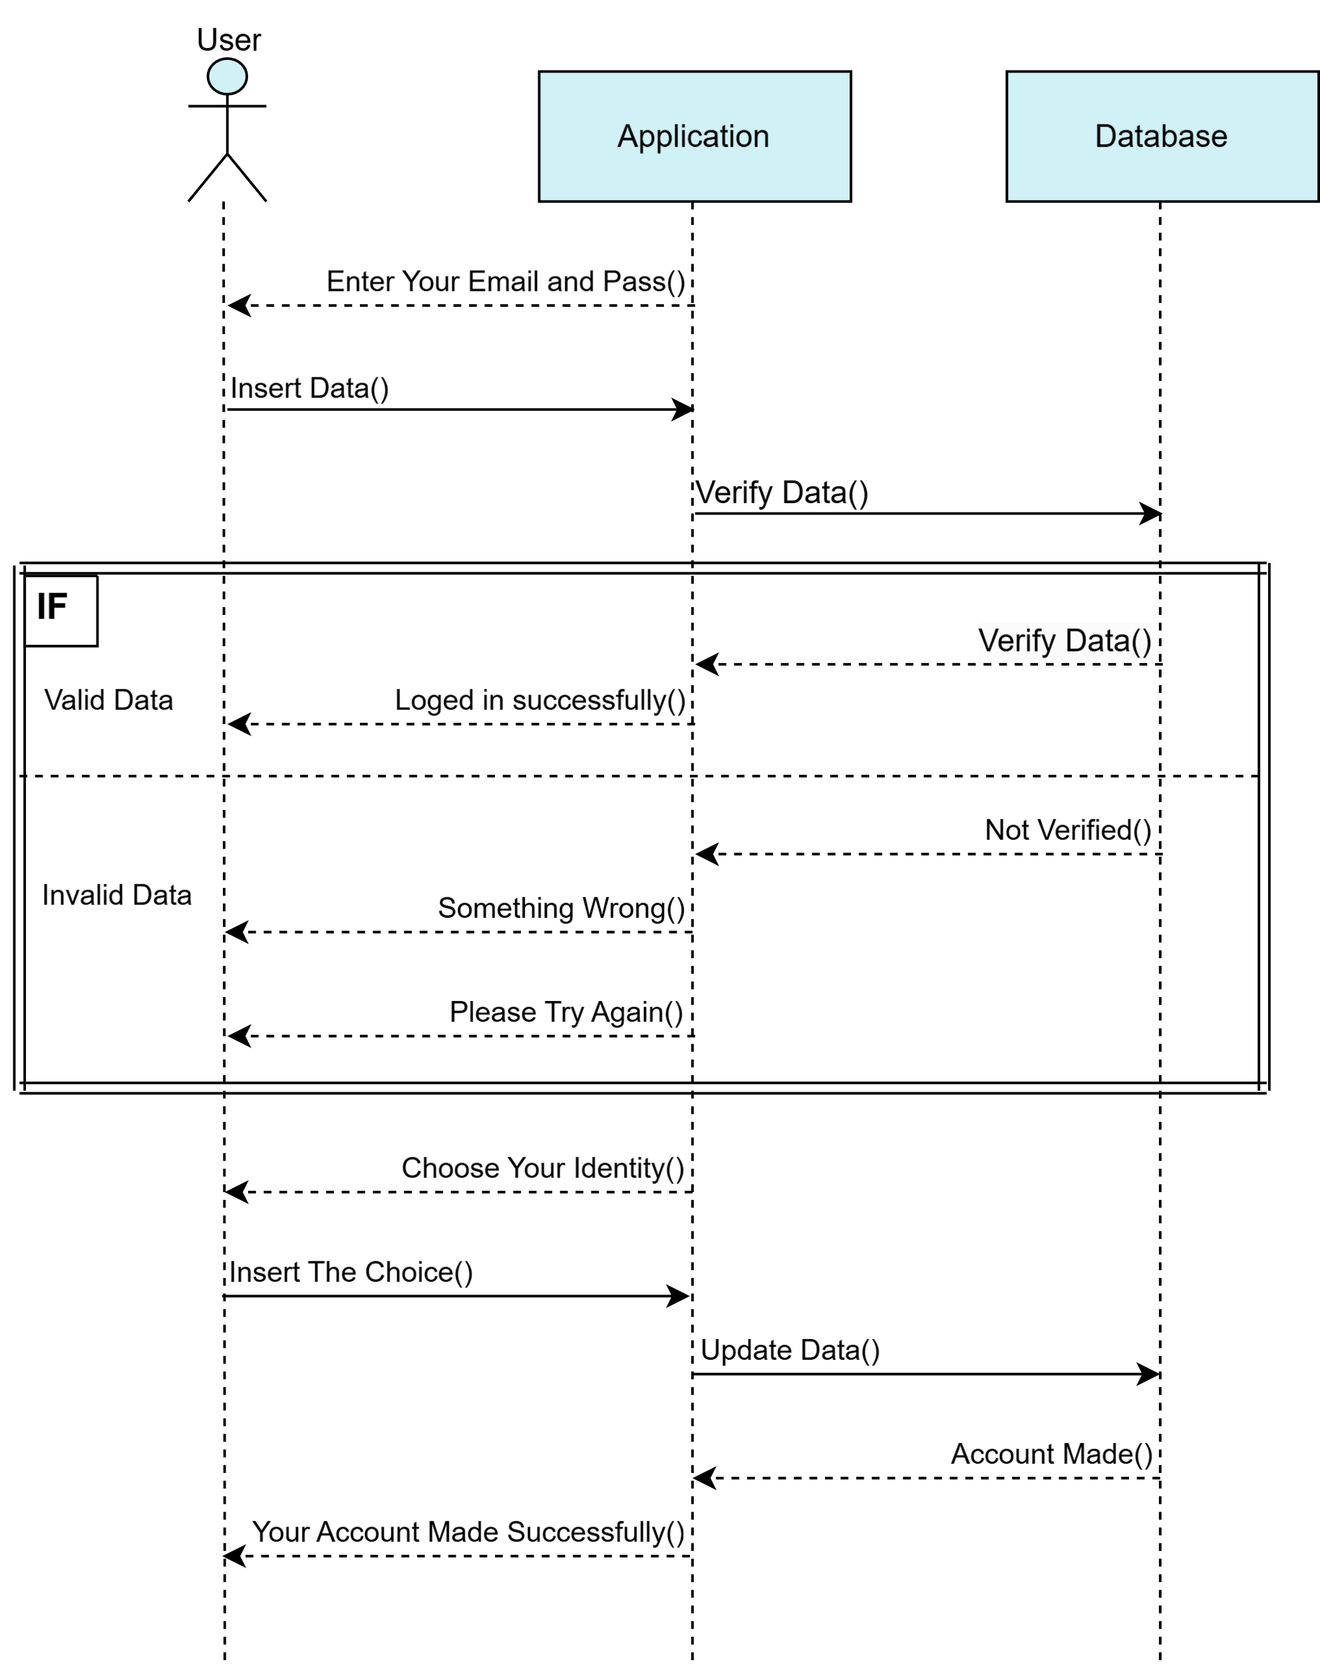

Figure ‎3.3: Authorization sequence diagram

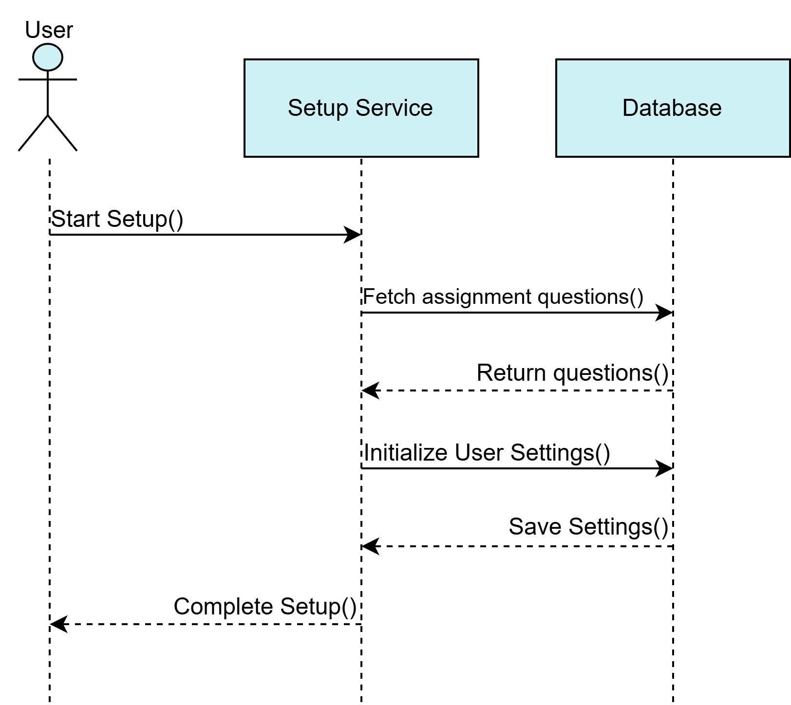

Figure ‎3.4: First-time setup sequence diagram

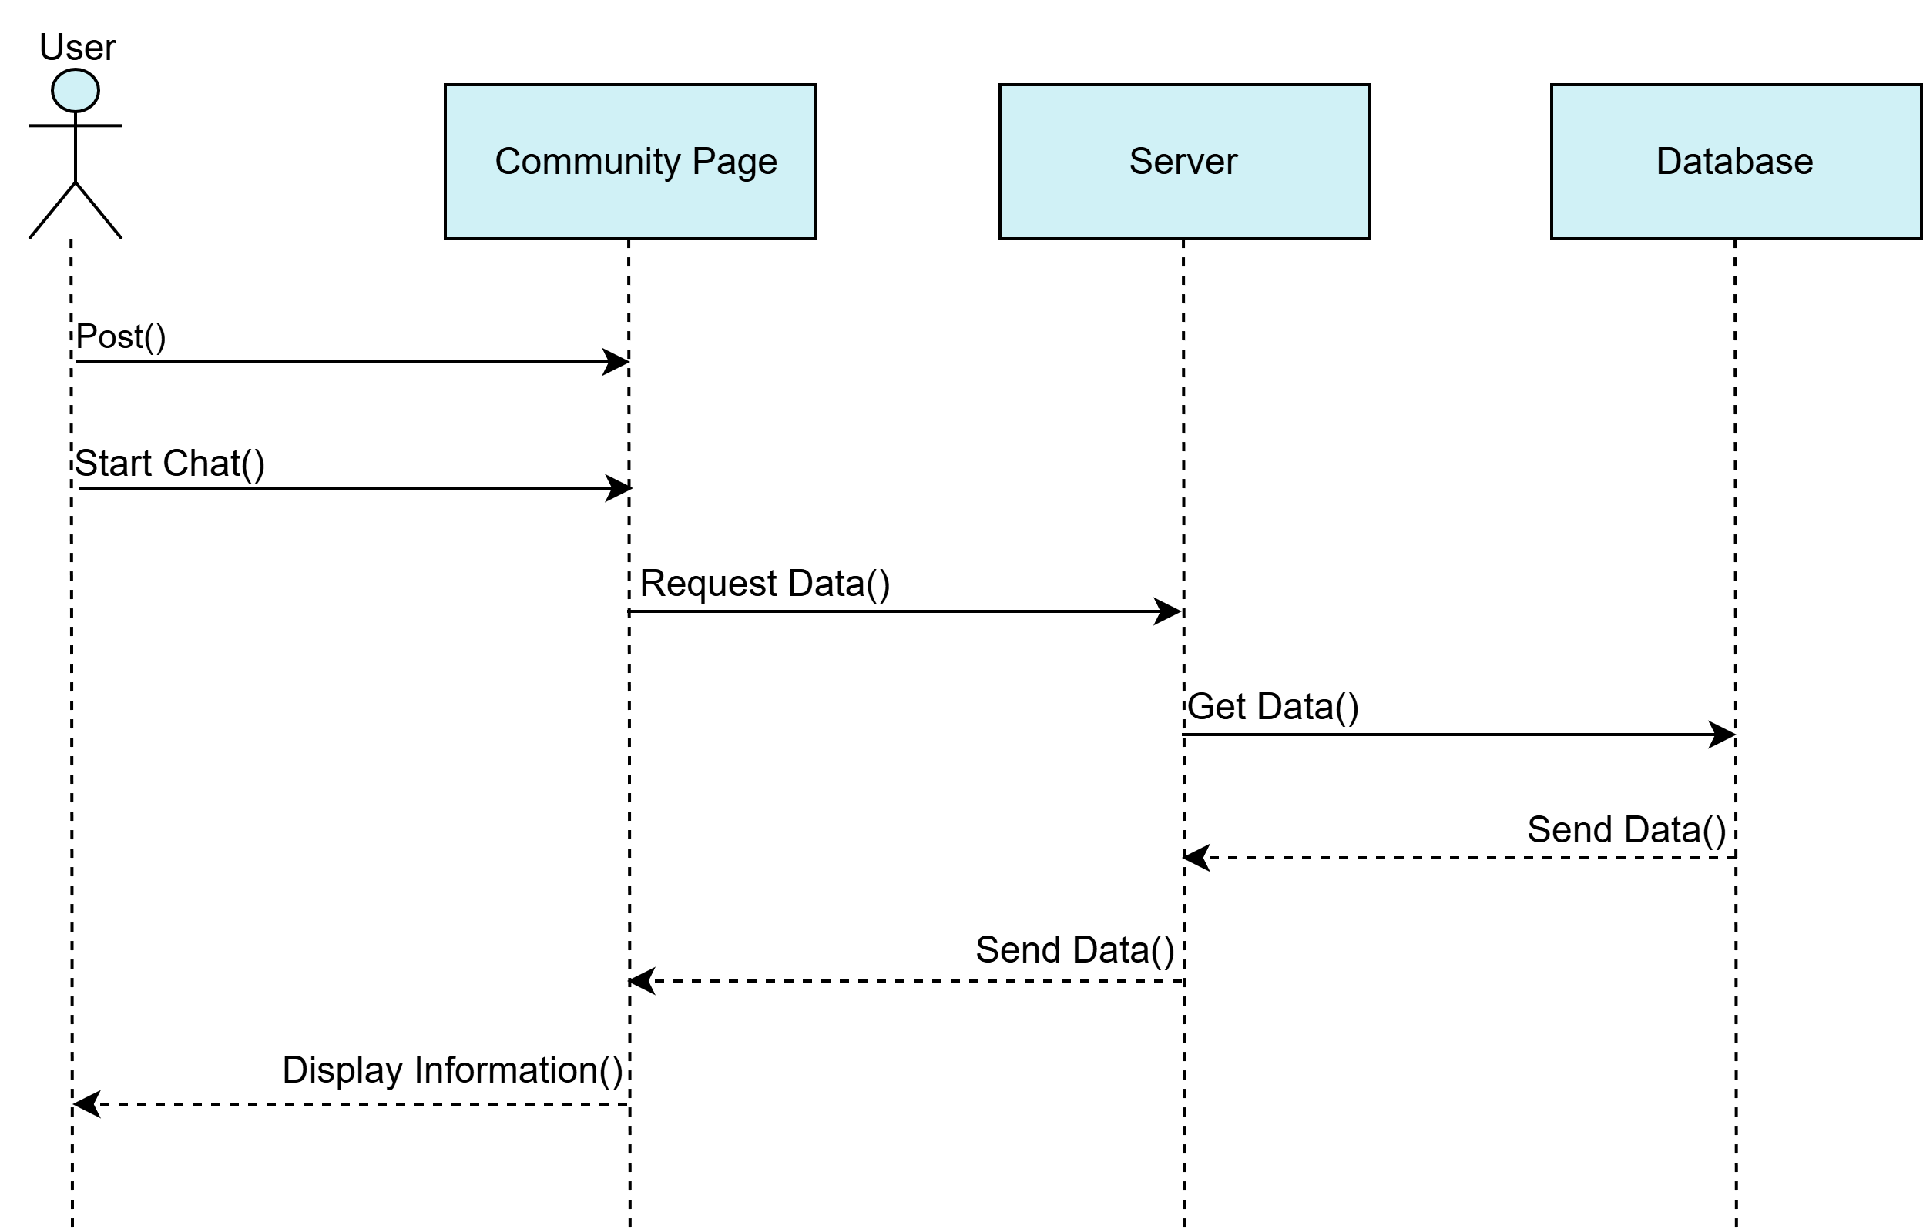

Figure ‎3.5: Community Forum sequence diagram

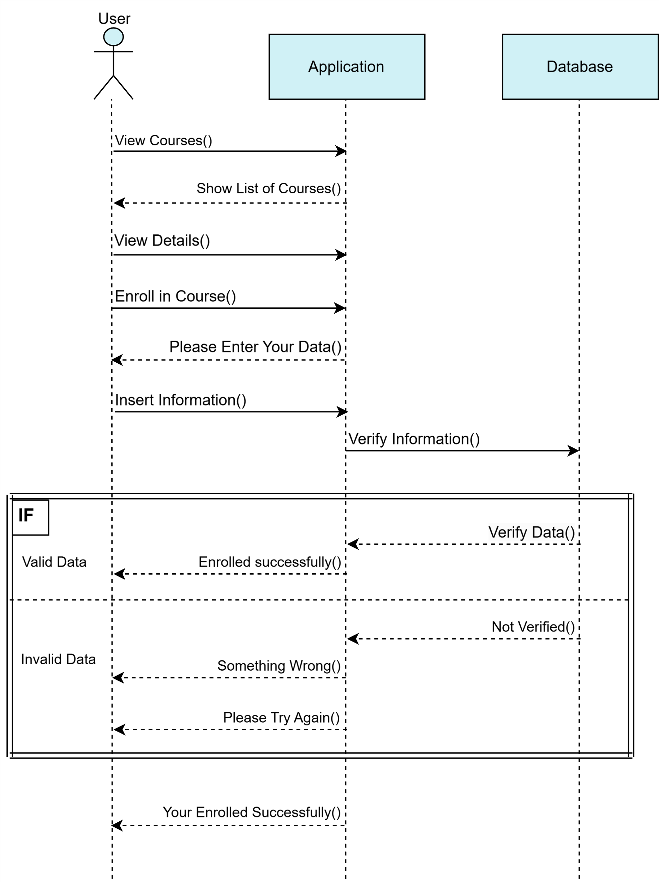

Figure ‎3.6: View Course sequence diagram

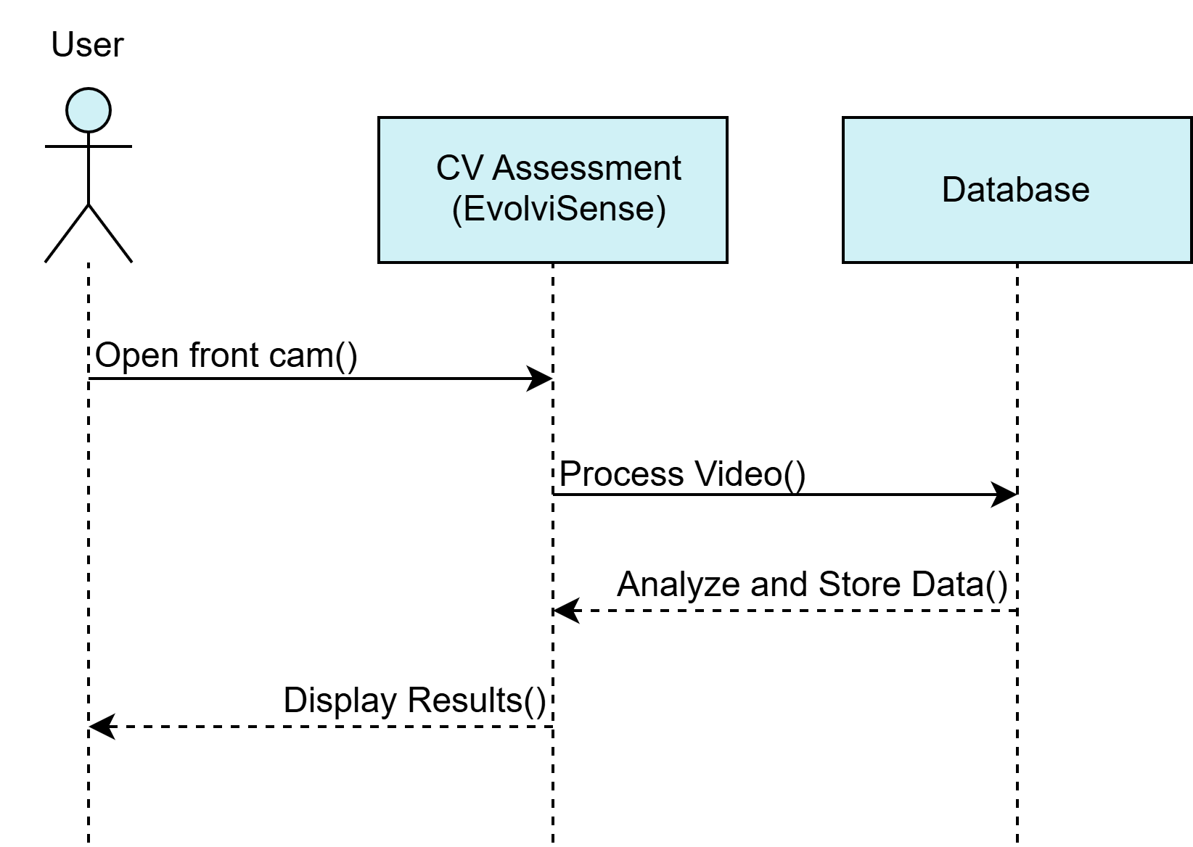

Figure ‎3.7: EvolviSense sequence diagram

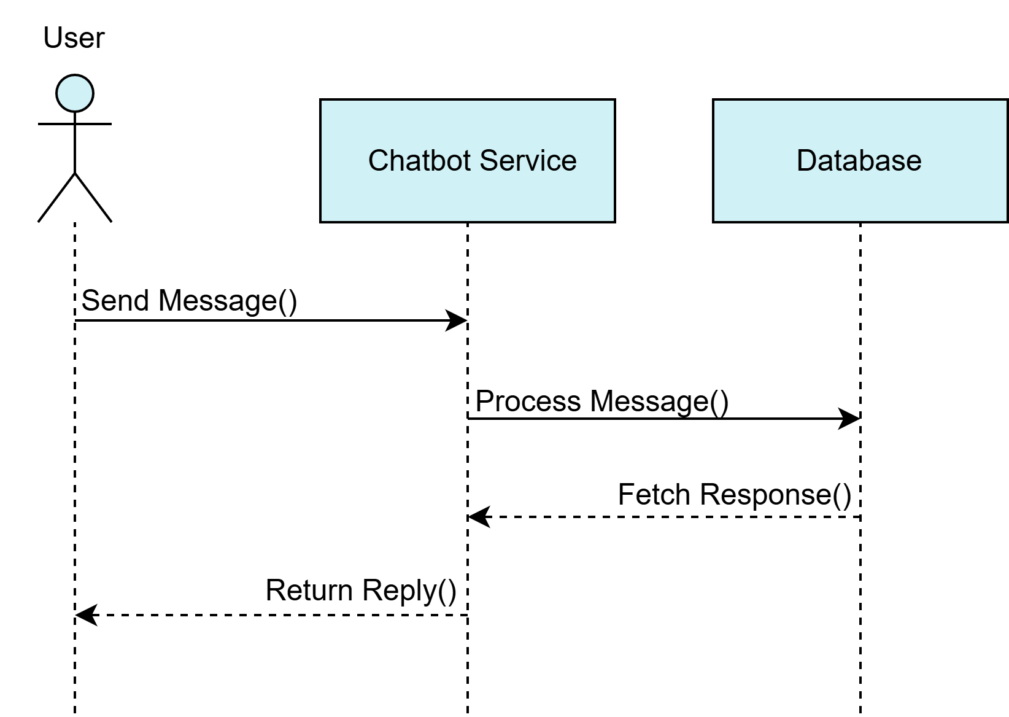

Figure ‎3.8: Chatbot sequence diagram

### Activity Diagrams

Having an idea about the flow process from one activity to anther in our system and the different dynamic aspect. The activity diagrams will show you what happened in the modelled system. we will show the flow process of each feature in our system in the following figures:

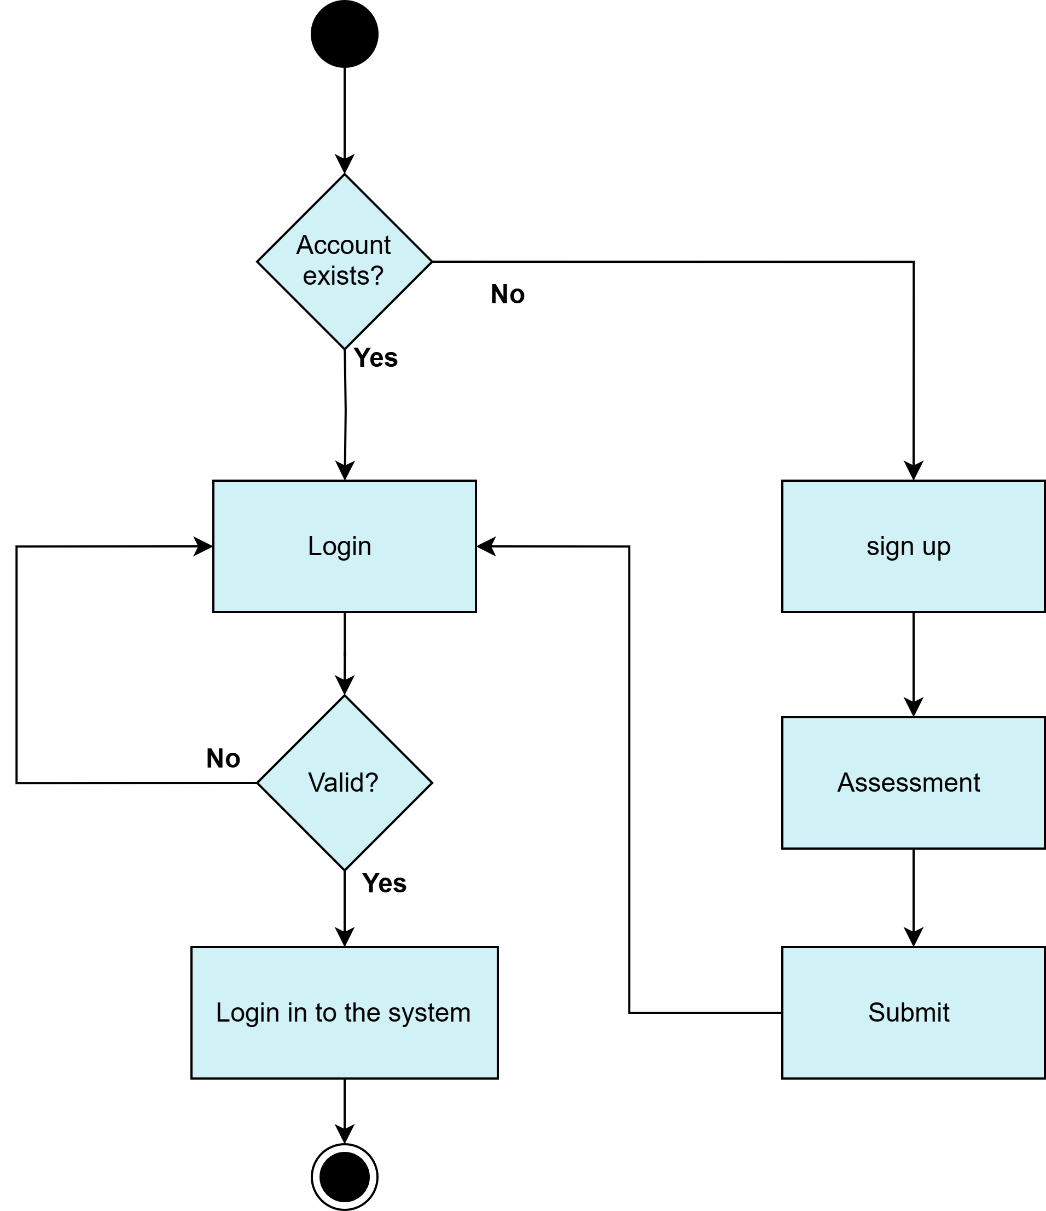

Figure ‎3.9: Authorization activity diagram

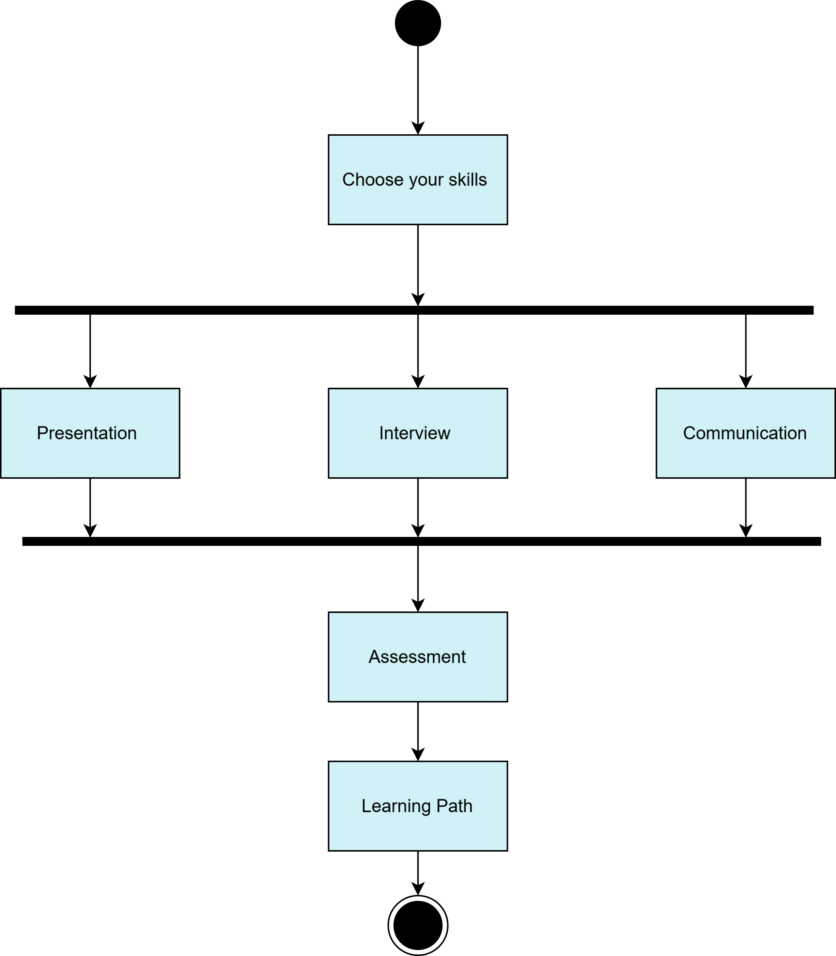

Figure ‎3.10: First-time setup activity diagram

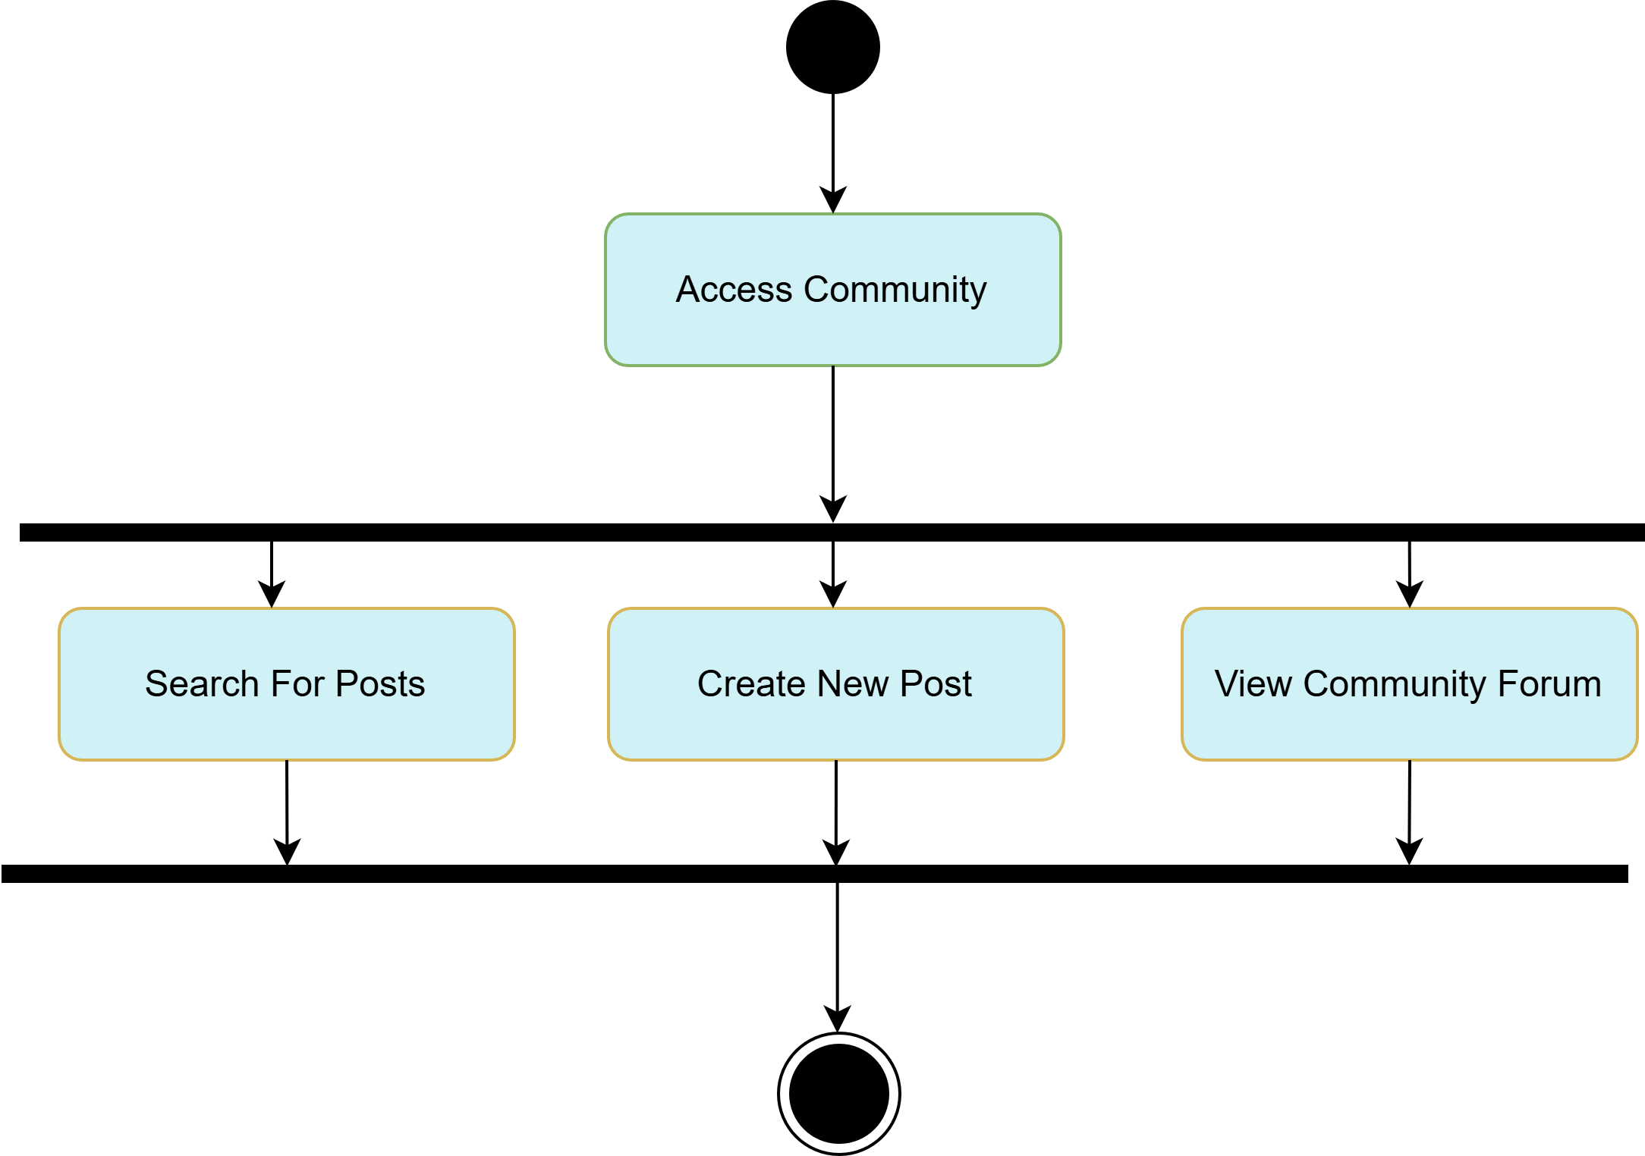

Figure ‎3.11: Community activity diagram

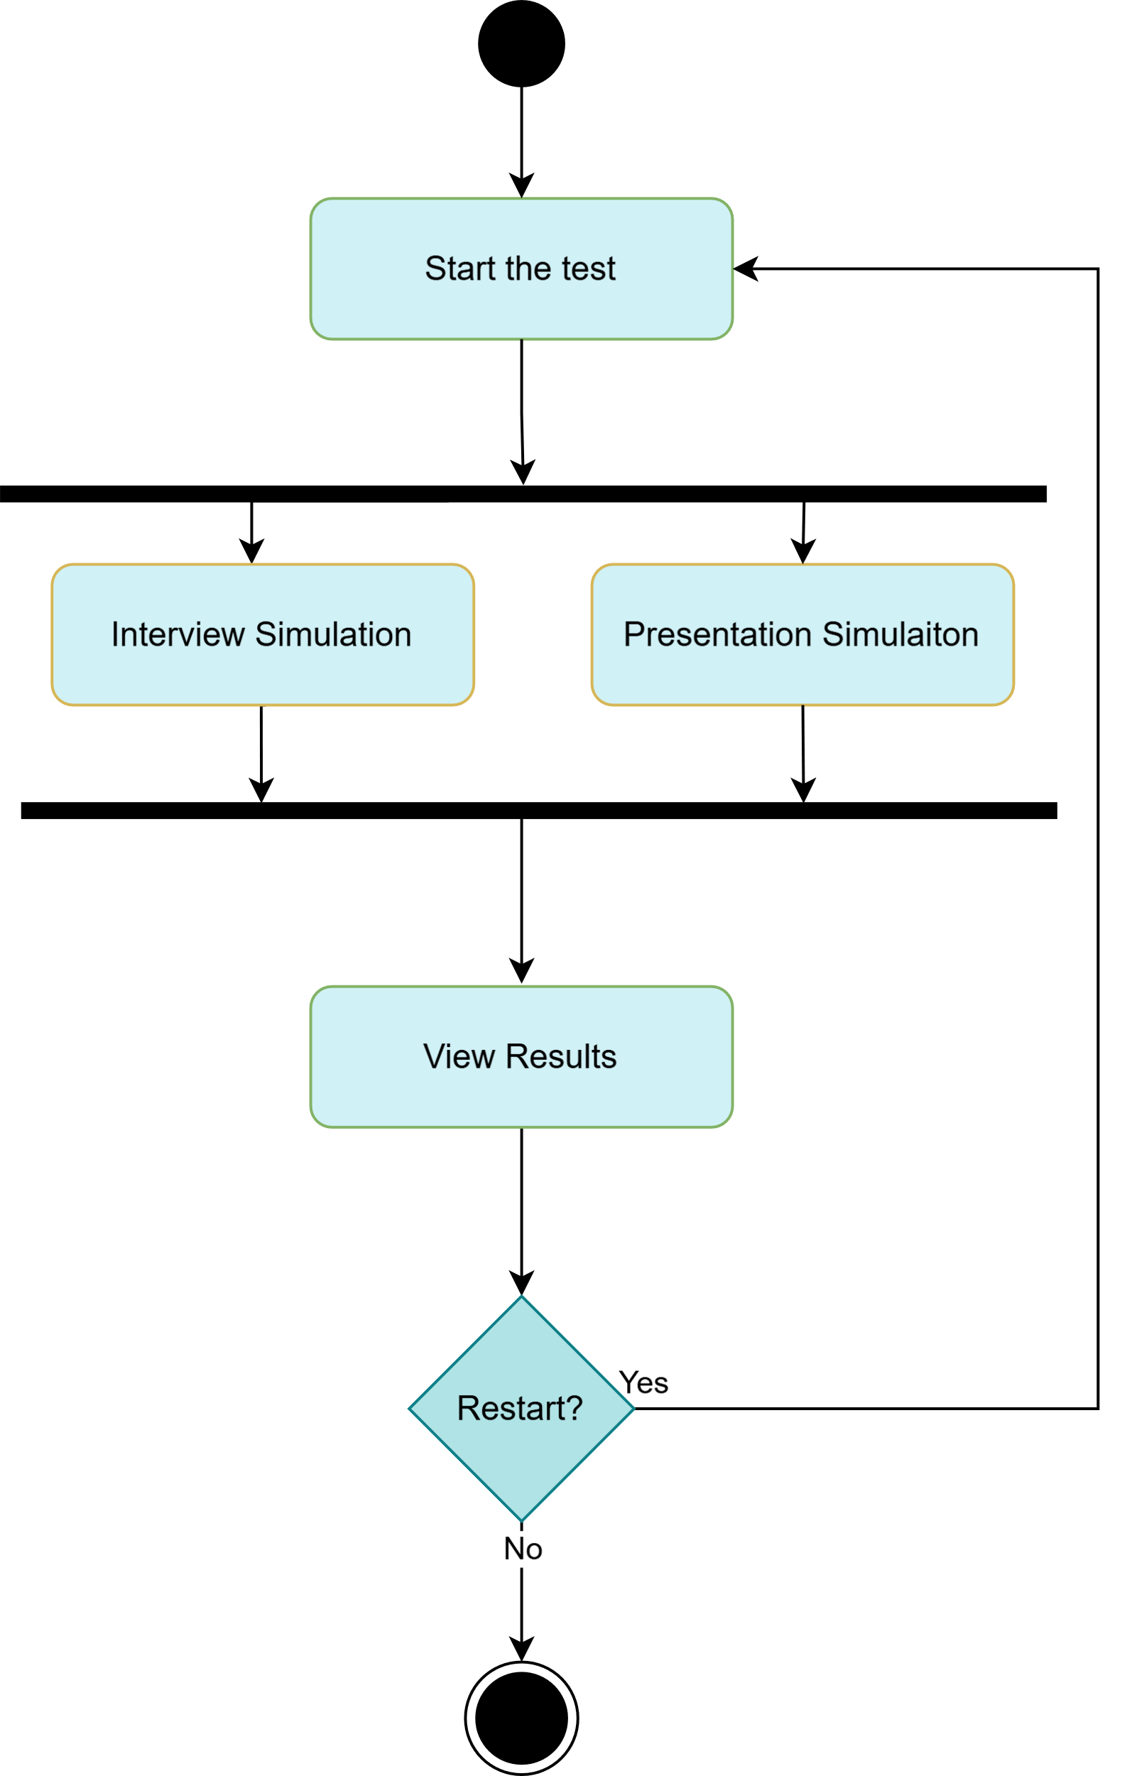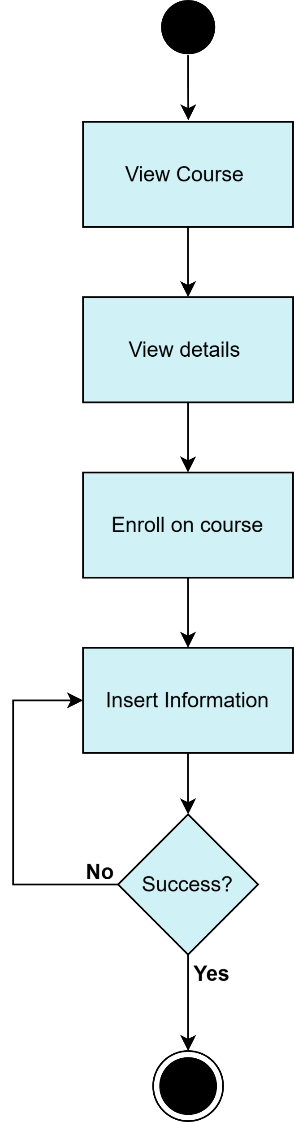

Figure ‎3.12: EvolviSense activity diagram

Figure ‎3.13: View course activity diagram

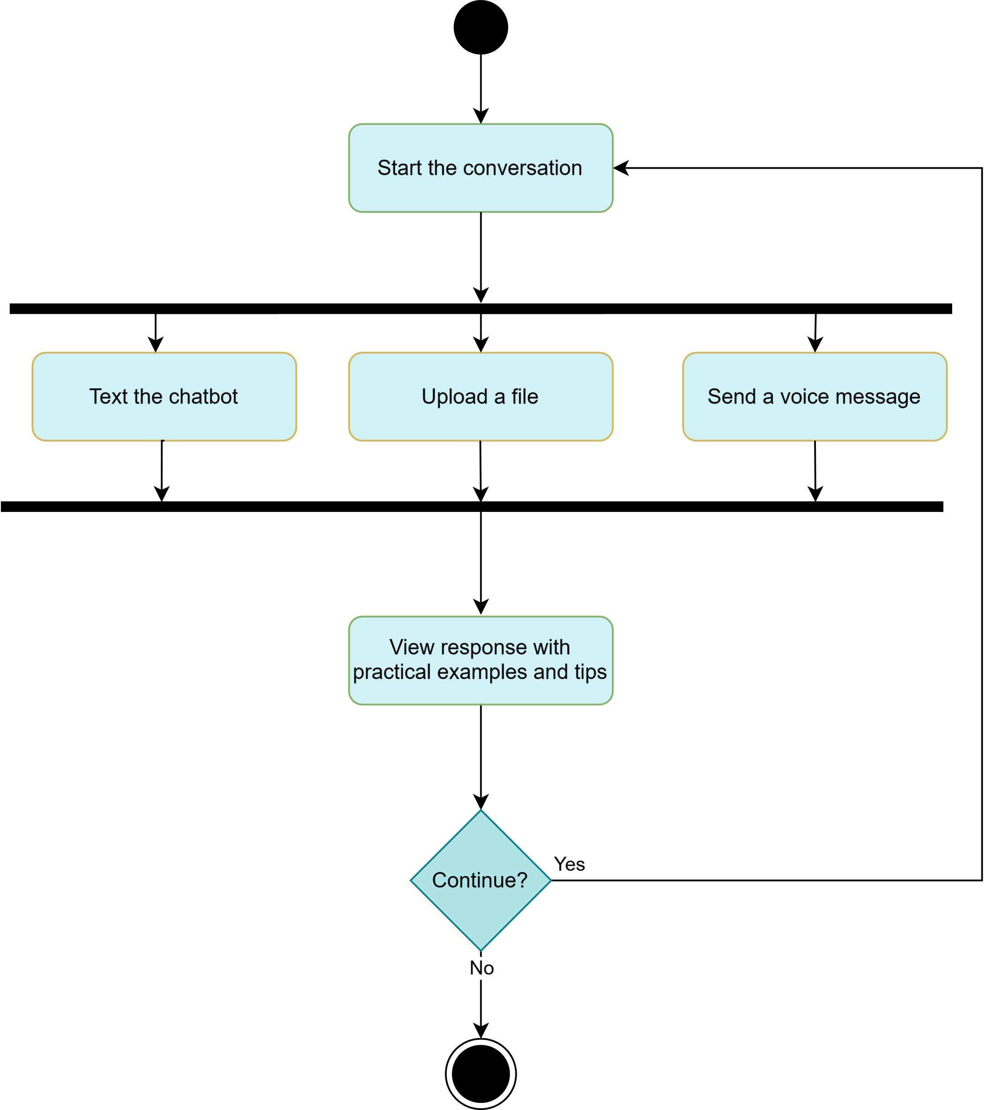

Figure ‎3.14: Chatbot activity diagram

### State Diagram

A state diagram gives an abstract description of the behaviour of the system that shows transitions between various objects. This behaviour is analysed and represented as a series of events that can occur in one or more possible states.

When the user opens the app, he will be directed to the start page, he has two choices, registration (sign up or log in) or skip registration and use it as a guest but the features will be limited.

If the user is a guest, he will be able to translate text and voice into sign language, also he can search about videos in the dictionary and display it.

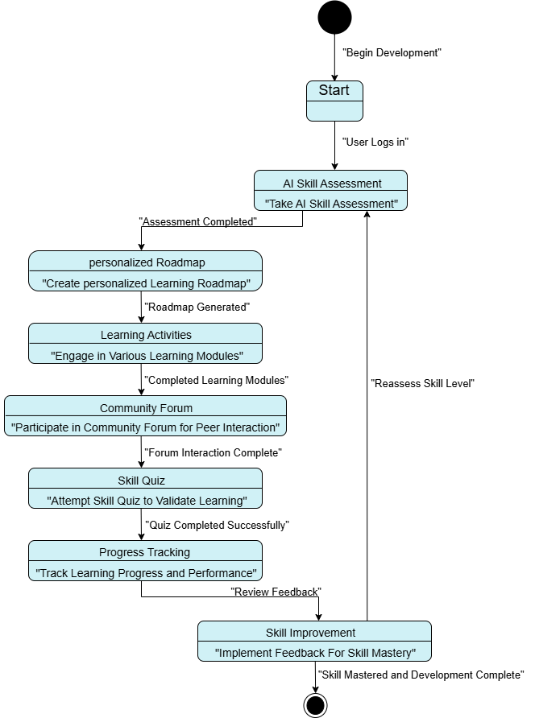If the user is registered, he will be able to translate text and voice into sign language and vice versa from sign language videos into readable words, also he can download more videos to the dictionary if they do not exist

Figure ‎3.15: State diagram for the project

## Summary

The Development Methodology section offers a structured approach to understand and fulfil the platform's requirements. By using Use Case Diagrams and detailed descriptions, we capture essential functionalities. UML Diagrams illustrate component interactions, ensuring that our design is robust, user-centered, and adaptable.

# System Design



## Introduction

Video provides a powerful way to help you prove your point. When you click Online Video, you can paste in the embed code for the video you want to add. You can also type a keyword to search online for the video that best fits your document.

To make your document look professionally produced, Word provides header, footer, cover page, and text box designs that complement each other. For example, you can add a matching cover page, header, and sidebar. Click Insert and then choose the elements you want from the different galleries.

Themes and styles also help keep your document coordinated. When you click Design and choose a new Theme, the pictures, charts, and SmartArt graphics change to match your new theme. When you apply styles, your headings change to match the new theme.

Save time in Word with new buttons that show up where you need them. To change the way a picture fits in your document, click it and a button for layout options appears next to it. When you work on a table, click where you want to add a row or a column, and then click the plus sign.

Reading is easier, too, in the new Reading view. You can collapse parts of the document and focus on the text you want. If you need to stop reading before you reach the end, Word remembers where you left off - even on another device.

# System Implementation



## Introduction

Video provides a powerful way to help you prove your point. When you click Online Video, you can paste in the embed code for the video you want to add. You can also type a keyword to search online for the video that best fits your document.

To make your document look professionally produced, Word provides header, footer, cover page, and text box designs that complement each other. For example, you can add a matching cover page, header, and sidebar. Click Insert and then choose the elements you want from the different galleries.

Themes and styles also help keep your document coordinated. When you click Design and choose a new Theme, the pictures, charts, and SmartArt graphics change to match your new theme. When you apply styles, your headings change to match the new theme.

Save time in Word with new buttons that show up where you need them. To change the way a picture fits in your document, click it and a button for layout options appears next to it. When you work on a table, click where you want to add a row or a column, and then click the plus sign.

Reading is easier, too, in the new Reading view. You can collapse parts of the document and focus on the text you want. If you need to stop reading before you reach the end, Word remembers where you left off - even on another device.

# Conclusion and Future Work



## Conclusion

Video provides a powerful way to help you prove your point. When you click Online Video, you can paste in the embed code for the video you want to add. You can also type a keyword to search online for the video that best fits your document.

## Future Work

Video provides a powerful way to help you prove your point. When you click Online Video, you can paste in the embed code for the video you want to add. You can also type a keyword to search online for the video that best fits your document.

To make your document look professionally produced, Word provides header, footer, cover page, and text box designs that complement each other. For example, you can add a matching cover page, header, and sidebar. Click Insert and then choose the elements you want from the

# References

**There are no sources in the current document.**